CST8503 Lab4 Prolog Lists

Overview

We build on your experience from previous labs to write programs involving Prolog lists.

When you have finished this lab exercise, you will have the ability to
- Write procedures to implement predicates that deal with lists
- Use simple Prolog arithmetic to solve problems.
- Use a graphical tracing utility to watch your programs execute

Prolog List Exercises

Write each of the following predicates in Prolog (this is to say, write a procedure to implement each of the following predicates).
- Write a predicate mycount(List,Count) which is true if Count is the number of items of the list, List
  - first think of the base case, the empty list,
  - then think of the general case
  - You will need to do arithmetic with "is"
  - Sample queries:
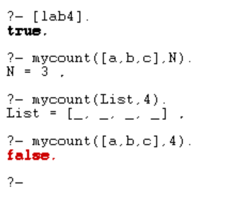

- Using the built-in predicate append/3, write a predicate nth(N,List,Item) which is true if Item is the Nth item in list List.
  - Your predicate must be defined in terms of append/3
  - sample queries:
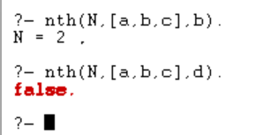

- Write a predicate funnylist(L) which is true if L is a funny list. For our purposes here, a funny list is any list where
- the list begins and ends with the same sublist,
- the sublist contains "w",
- the sublist has length is 5.

You may use the built-in append/3, member/2, and length/2 predicates, or use your own versions of those predicates if you like. HINT: you will want to use two append statements, and you should think carefully about which one comes first.

Sample queries
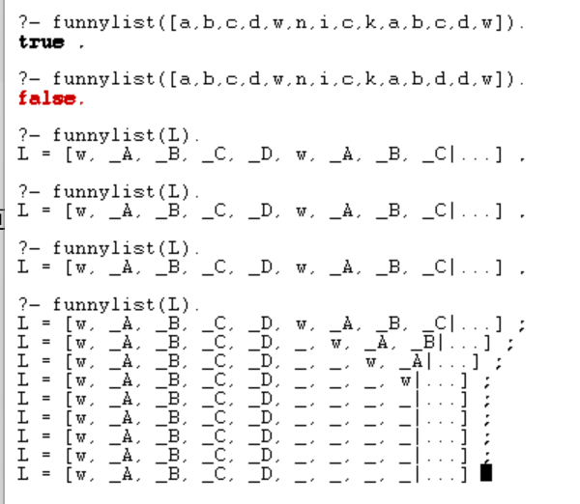

Demonstration

- Explain how your mycount predicate uses Prolog arithmetic to solve the problem.
- Run a successful query of a predicate chosen by your instructor
- Run an unsuccessful query of a predicate chosen by your instructor
- Show that you can run a graphical tracing utility to watch your program execute a query that fails

